Lab Exercise 22

Checking Vulnerabilities Using Trivy

Objective: To scan container images for vulnerabilities using Trivy to identify and mitigate security risks and ensure that containerized applications are secure
Tools required: Trivy
Prerequisites: None

Steps to be followed:
- Install Trivy
- Scan the vulnerabilities using Trivy

Step 1: Install Trivy
- Run the following command to install tools for secure downloads, HTTPS repositories, encryption key management, and system version identification:
sudo apt-get install wget apt-transport-https gnupg lsb-release
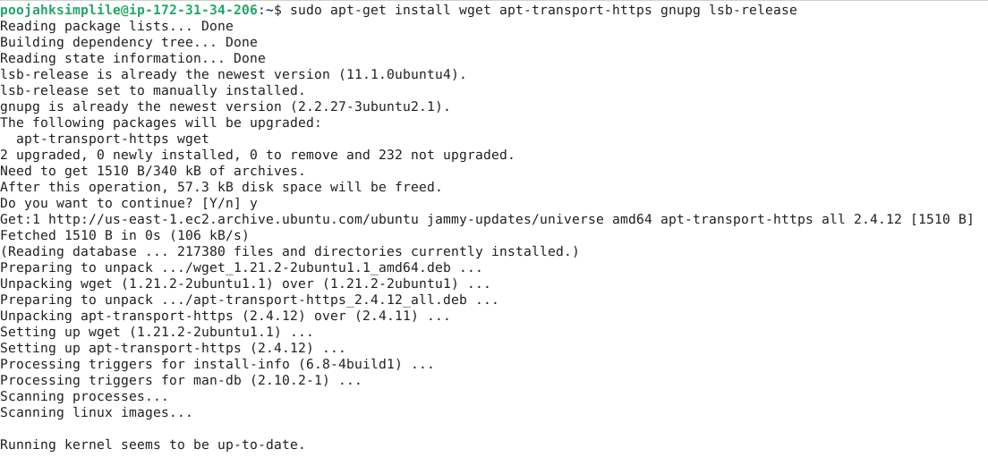

- Run the following command to download the Trivy repository's public key and add it to the system's trusted keys, ensuring secure package verification:
wget -qO - https://aquasecurity.github.io/trivy-repo/deb/public.key | sudo apt-key add -
OUTPUT:
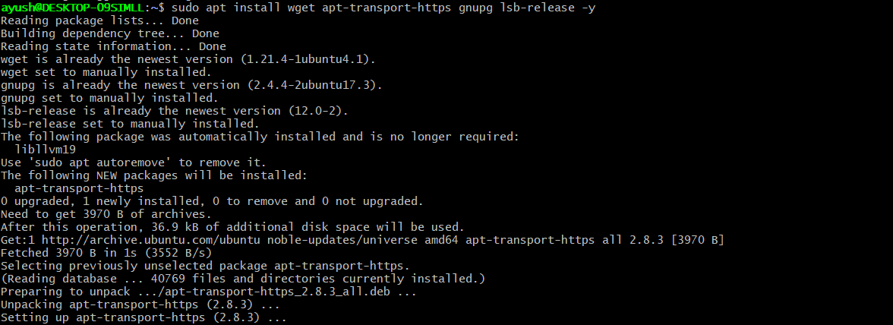

- Run the following command to add the Trivy repository to the system's sources list, enabling the installation of Trivy packages tailored to the Ubuntu version:
echo deb https://aquasecurity.github.io/trivy-repo/deb $(lsb_release -sc) main | sudo tee -a /etc/apt/sources.list.d/trivy.list

- Run the following command to update the system's package lists, ensuring the latest information on available software and updates from all configured repositories:
sudo apt-get update
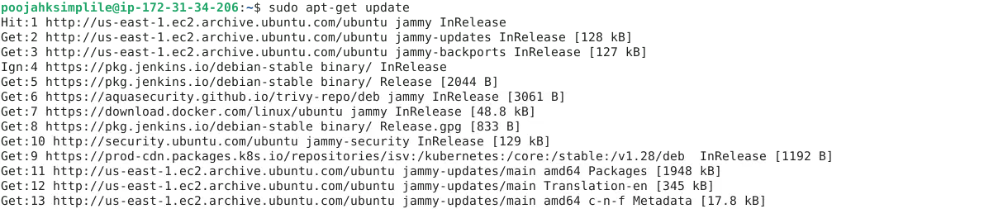

OUTPUT: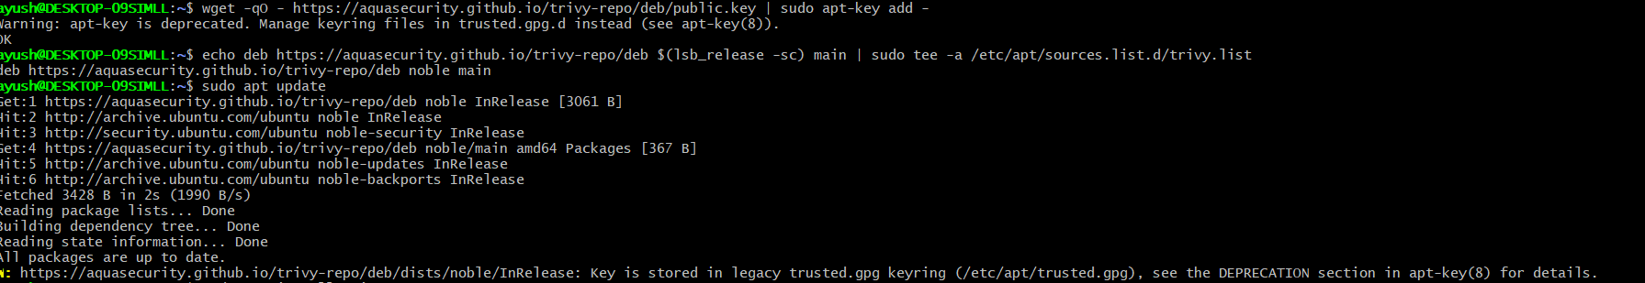

- Run the following command to install Trivy, a security scanner for containers, directly from the configured repository:
sudo apt-get install trivy
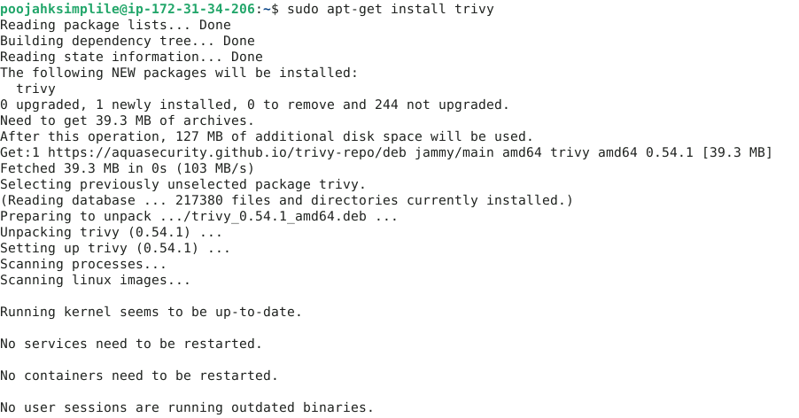

Step 2: Scan the vulnerabilities using Trivy

- Run the following command to scan the NGINX container image with Trivy for vulnerabilities and security issues:
trivy image nginx
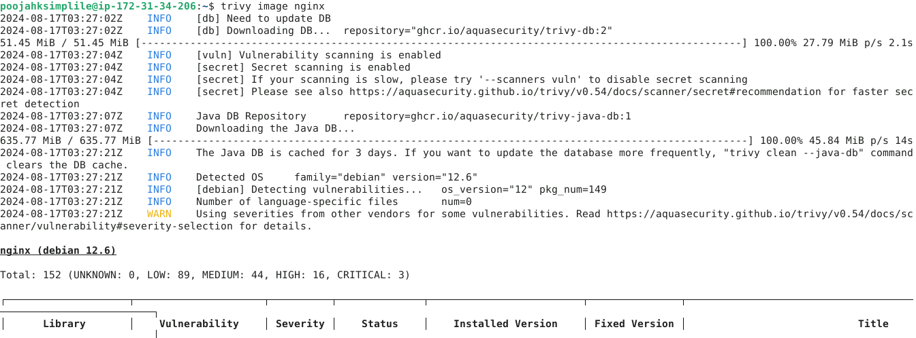
It shows the results of a Trivy security scan, listing vulnerabilities in installed packages, their severity, and whether they are affected. It also includes details like the installed version and links for more information.
OUTPUT:
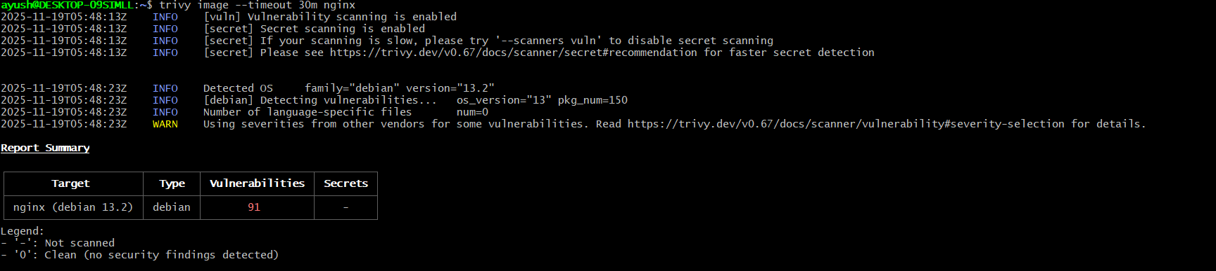

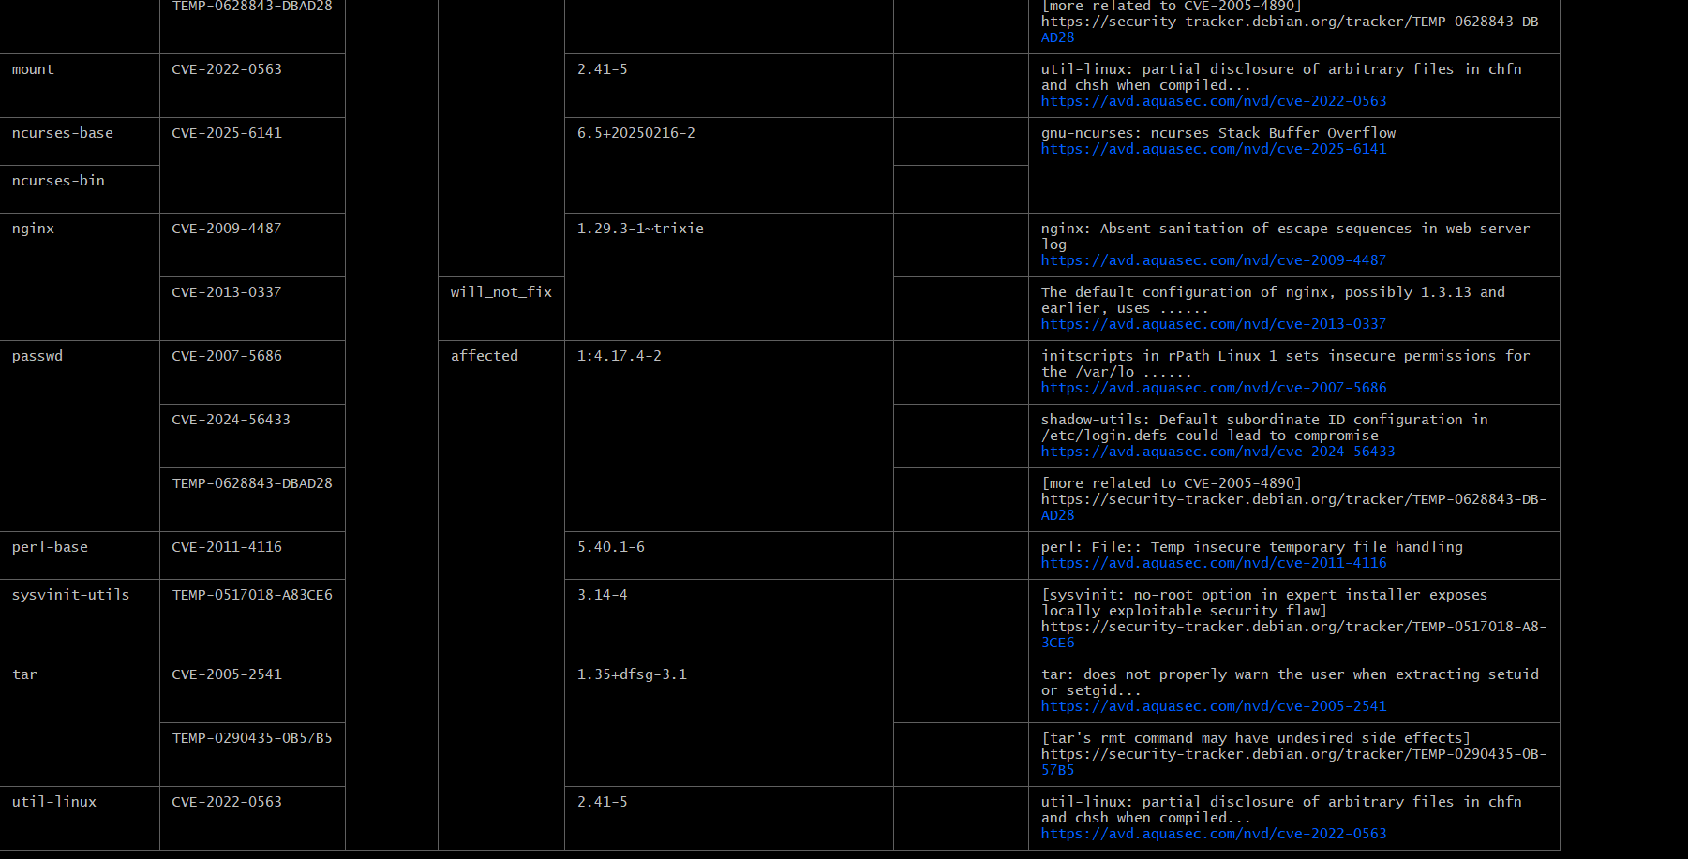

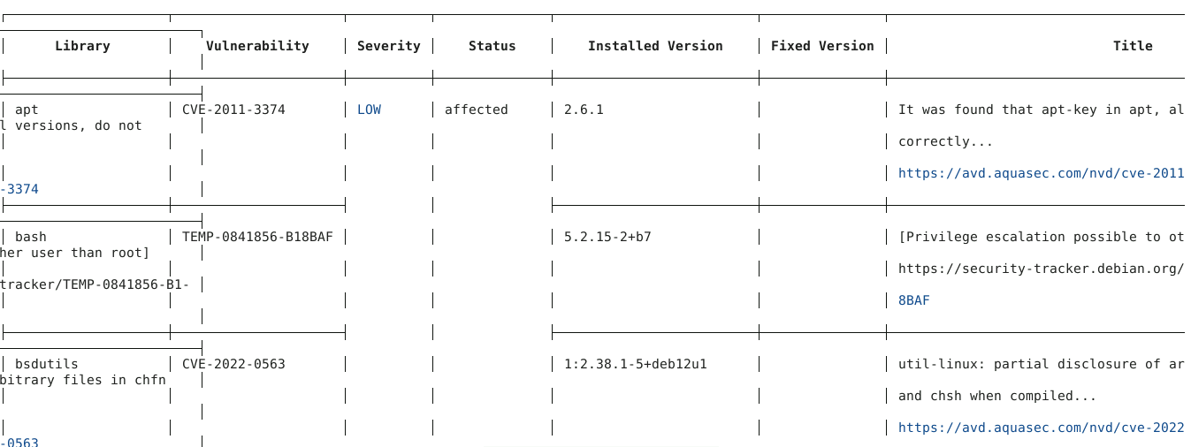

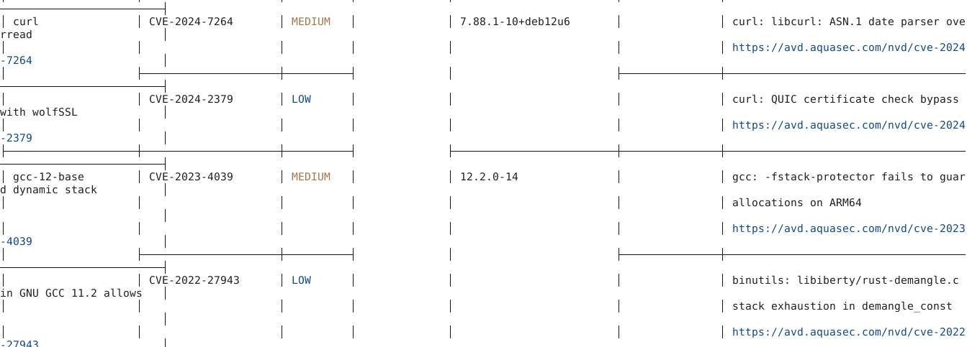
By following these steps, you have successfully scanned container images for vulnerabilities using Trivy to identify and mitigate security risks and ensure the security of containerized applications.

